

**ECE 5734**

Embedded Systems Verification & Validation

**Project Progress Report on**

VERIFICATION OF SAFETY AND SECURITY REQUIREMENTS IN AUTONOMOUS VEHICLE

**By**

Cory Ness

Kokila Subramanian

**Under the Guidance of**

Professor Ramesh Sethu

Winter 2022

# **Introduction**

Concept of connected devices and cooperative and intelligent self-driving transportation systems are thriving the economy over the past decade. Society of Automobile engineering (SAE) have defined 5 levels of automation depending on its functionalities and capabilities. Today’s commercially available autonomous vehicle systems have reached the 4th level of autonomy. The major constraint of autonomous vehicle in urban traffic should be capable of navigating through the varying city’s traffic conditions, perform complex maneuvers like parking, moving at intersections, merging in lane, and must operate with the diverse geographical boundary conditions. Verification and validation of the requirements of the system can add trustworthiness to the autonomous system under development.

# **Objective of Project**

This project aims to develop a model and verify the functional requirements of an autonomous vehicle system using the LabVIEW simulation tool. The autonomous vehicle model developed was based primarily on physics and research done by others, which we implement in LabVIEW. To identify the safety requirements of autonomous driving system that includes obstacle detection, maintain stability, automatic transmission control and accidental failure prevention. Using the model, we will attempt to drive the vehicle based on the safety requirements of the currently running test and verify that the model’s outputs are within acceptable safety criteria for the test that’s running.

# **Safety Requirements**

Understanding the autonomous vehicle model, the dynamic behavior and evaluating the functionalities involves two wide process, verification and validation, implemented from the early stage of the product development. The safety requirements definition for autonomous vehicles are listed under the following factors:

* Determine Location of the vehicle with the use of perceptional sensors and environmental conditions.
* Perceive relevant static and Dynamic Objects in Proximity using the traffic condition and sensor data
* Predict Future Behavior of Surrounding Objects from the perceived data.
* Create Collision Free and Lawful Driving Plan by interpreting the information collected from environment and ADS manger.
* Execute and Actuate right Driving Plan by controlling the actuators.
* Communication with other Road users
* Ensure Controllability of Vehicle with seamless braking, lane control and object detections capabilities.

# **Kinematics and Dynamic Autonomous Vehicle Model using LabVIEW**

## **Model Based Car Simulation**

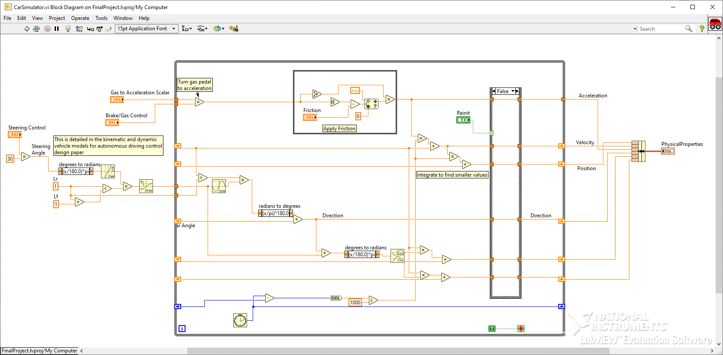The kinematics and dynamic Car simulator model is developed using LabVIEW simulation tool. It provides the physical variables of the autonomous vehicle based on the inputs over simulation time.

Figure 1. Car Simulator Block Diagram

## **Test Generator**

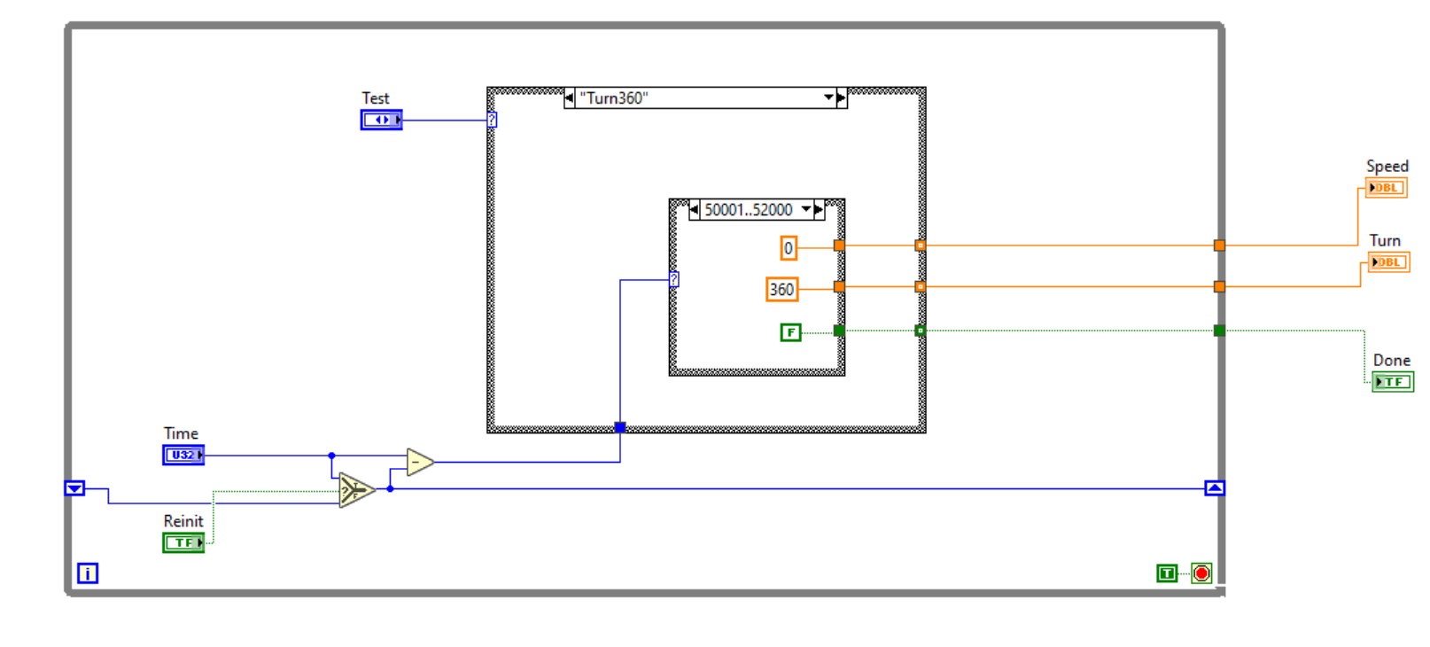The Test Generator is used to select the targets for the model to verify the Test cases for the safety requirements defined. It specifies the Test cases to run among the various test cases listed.

Figure 2. Test Generator Block Diagram

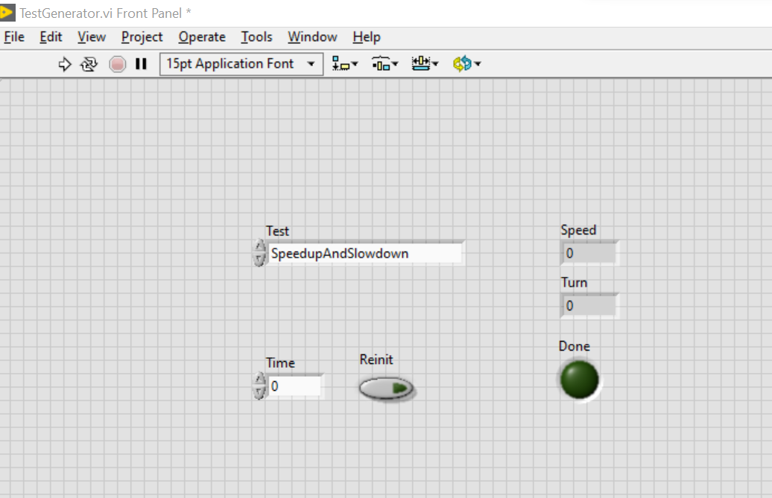

Figure 3. Test Generator Front Panel

# **Completed goals of the project**

1. Developed model of the autonomous vehicle implementing the algorithms and equations present in “Kinematic and Dynamic Vehicle Models for Autonomous Driving Control Design”. While creating the model was very insightful, using already present methods and designs for the autonomous model allowed us to quickly get up and running, focusing largely on the goals of the project which include verification and validation.
2. Implemented some safety requirements tests to verify that our current system behaves properly. These tests include driving straight at 60mph, speeding up to 20mph then braking to 0mph, and turning a full 360 degrees at 10mph. throughout the tests, we monitor the current speed and direction of the vehicle to ensure if it is within safety requirements of an autonomous vehicle.

# **Modifications to the project**

Despite all the work that’s gone into the project and that’s succeeded, the model requires slight modification to reduce the scope and make it more achievable. The biggest modification is in the model of the vehicle, is to focus on the desired requirements testing, planning from a different system and analyze its reactions, rather focusing on simulating sensors. This allows to focus on the verification and validation of the project, as opposed to getting sucked into the model and how to best represent the validated autonomous vehicle model.

# **Next steps in the project**

* Include additional more complex safety requirement tests such as, obstacle avoidance, lane changing, and back-in parking.
* Create tests that simulate scenarios that an autonomous vehicle may find itself in.
* Add more criteria to look through at through the model, potentially the x-y position against what we know are thresholds in the test, such as in the obstacle avoidance test in order to ensure the car never reaches a position that causes it to collide with the obstacle.

### **References**

1. Ailon, A., Berman, N., & Arogeti, S. (2005). On controllability and trajectory tracking of a kinematic vehicle model. *Automatica*, *41*(5), 889–896. https://doi.org/10.1016/j.automatica.2004.11.025
2. *Benz: Safety First for automated driving.* Mercedes. (2019, July 4). https://www.mercedes-benz.com/en/innovation/safety-first-for-automated-driving/?csref=sm_fbk_gims2019_pc.html
3. Kang, C. M., Lee, S.-H., & Chung, C. C. (2018). Multirate Lane-keeping system with kinematic vehicle model. *IEEE Transactions on Vehicular Technology*, *67*(10), 9211–9222. https://doi.org/10.1109/tvt.2018.2864329
4. Kong, G., Pfeiffer, Mark., Schildbach, G., and Borrelli, F. *Kinematic and dynamic vehicle models for Autonomous Driving Control Design*. IEEE Xplore. (n.d.). https://ieeexplore.ieee.org/document/7225830
5. Sabaliauskaite, G., Liew, L., & Cui, J. (1970, January 1). *[PDF] Integrating Autonomous Vehicle Safety and security analysis using STPA method and the six-step model: Semantic scholar*. undefined. https://www.semanticscholar.org/paper/Integrating-Autonomous-Vehicle-Safety-and-Security-Sabaliauskaite-Liew/dcc9ab963f2f4d97b5dc81d0e8df0708008d36a8